Request:

<soap:Envelope xmlns:soap="http://www.w3.org/2003/05/soap-envelope" xmlns:typ="http://sample.com/reservation/guest/types">

<soap:Header/>

<soap:Body>

<typ:getEmployeeDetails>

<!--Optional:-->

<typ:employeeName>moon</typ:employeeName>

</typ:getEmployeeDetails>

</soap:Body>

</soap:Envelope>

Response:

<soapenv:Envelope xmlns:soapenv="http://www.w3.org/2003/05/soap-envelope">

<soapenv:Body>

<ns:getEmployeeDetailsResponse xmlns:ns="http://sample.com/reservation/guest/types">

<ns:return xsi:type="ns:Employee" xmlns:ax21="http://exception.reservation.sample.com/xsd" xmlns:xsi="http://www.w3.org/2001/XMLSchema-instance">

<ns:age>32</ns:age>

<ns:department>IT</ns:department>

<ns:id>2</ns:id>

<ns:name>Moon</ns:name>

</ns:return>

</ns:getEmployeeDetailsResponse>

</soapenv:Body>

</soapenv:Envelope>

* Verify Age attribute is displayed:

Use exists(//ns:age)

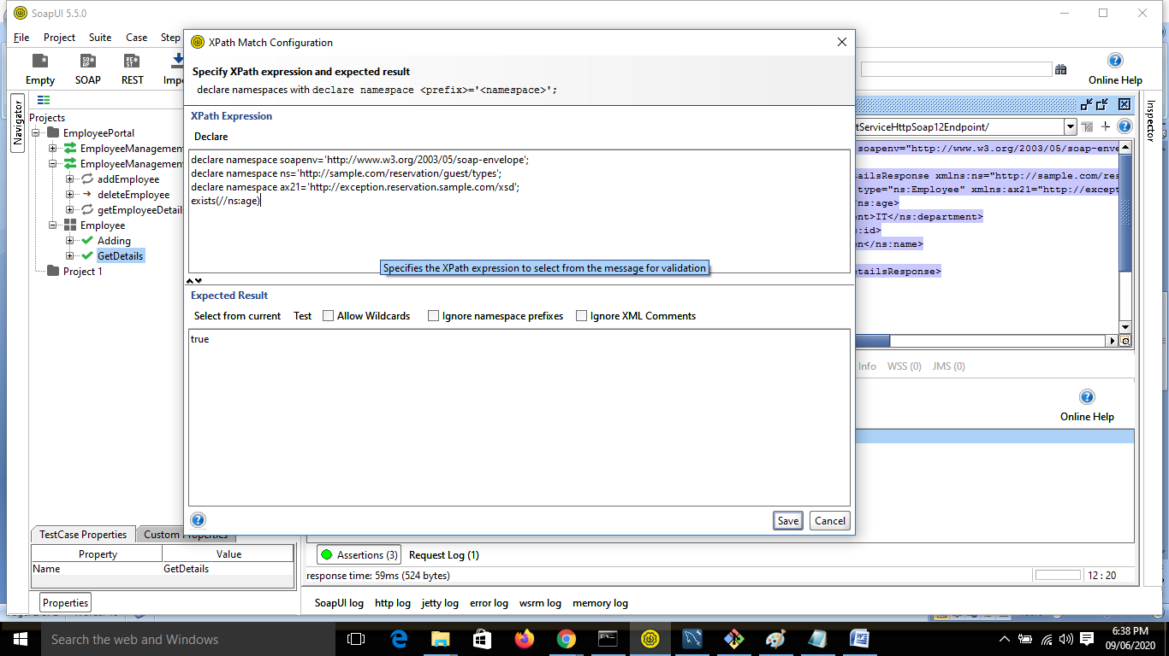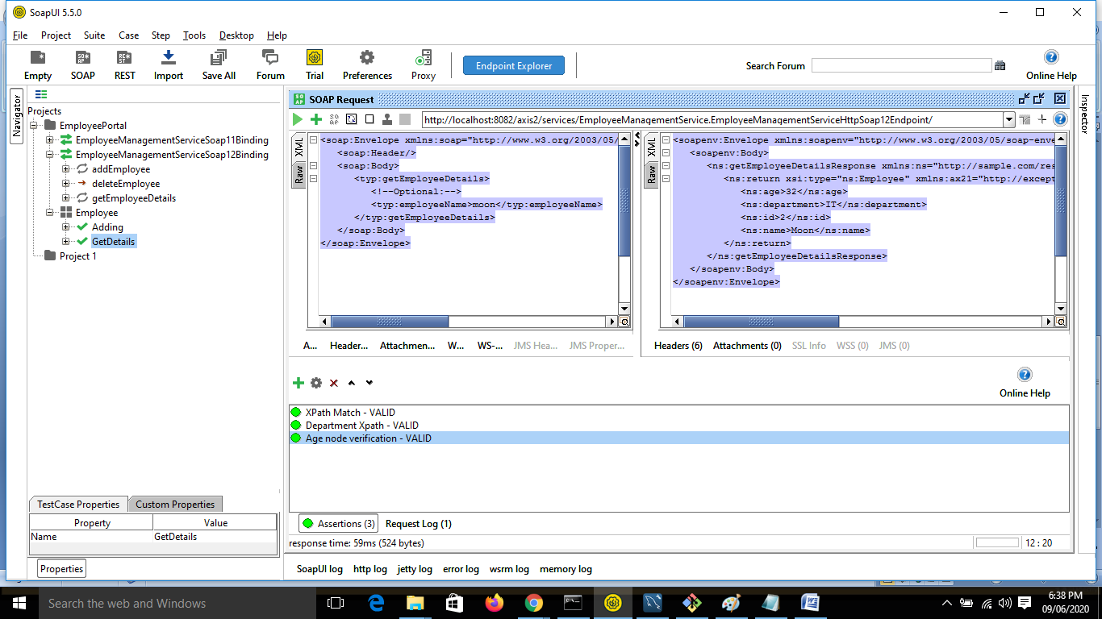

* Unique search result

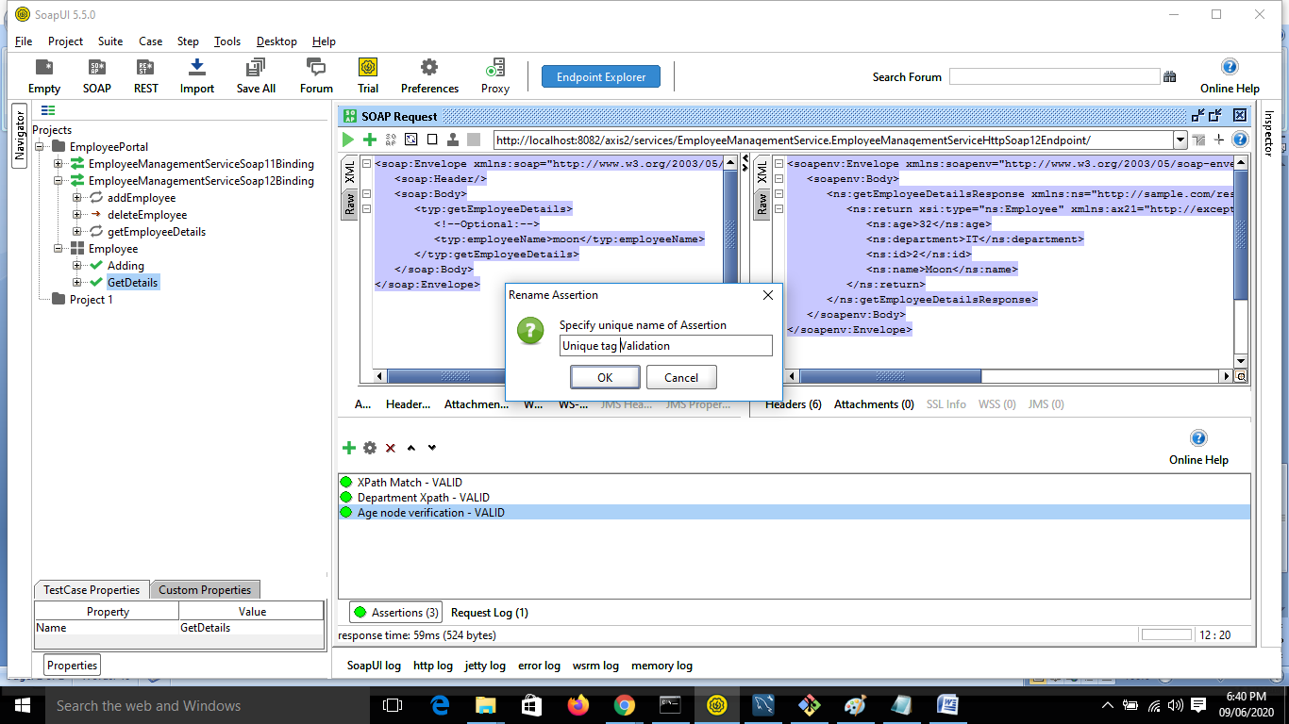

* count(//ns:name)

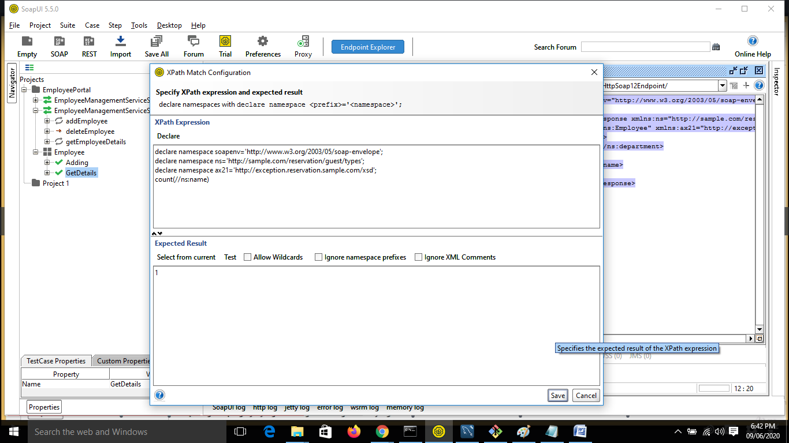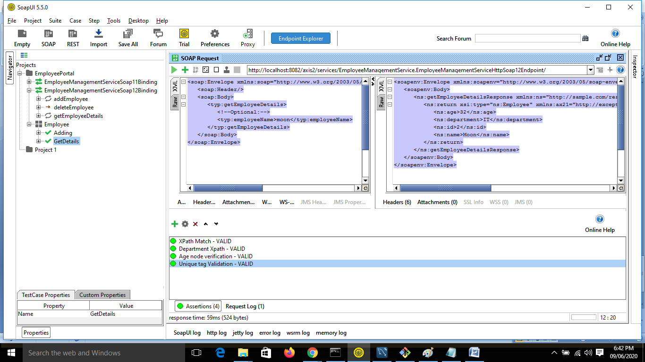

* Check wildcard responses:

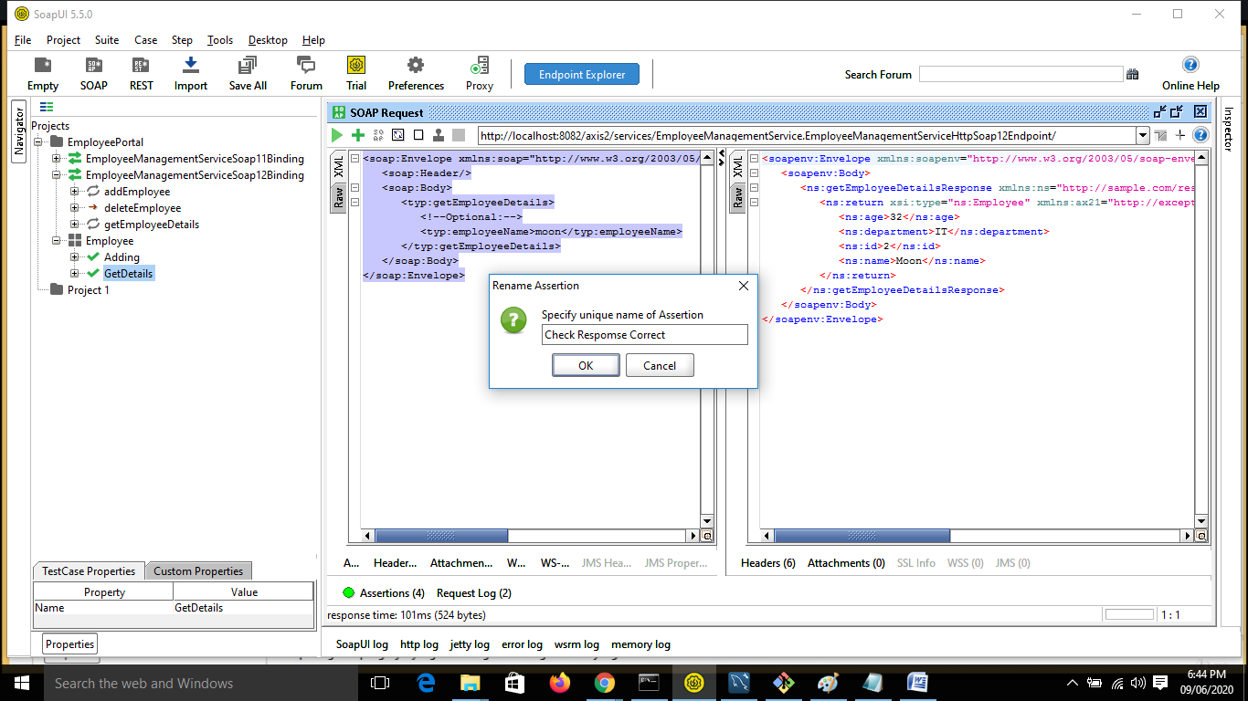

Press Select from current:

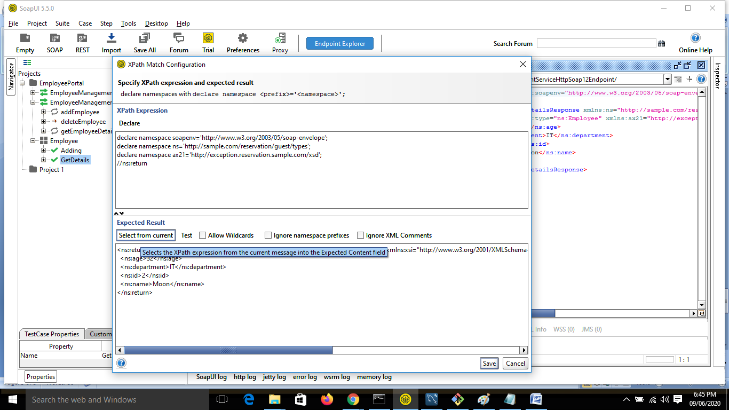

Click Allow Wild Cards:

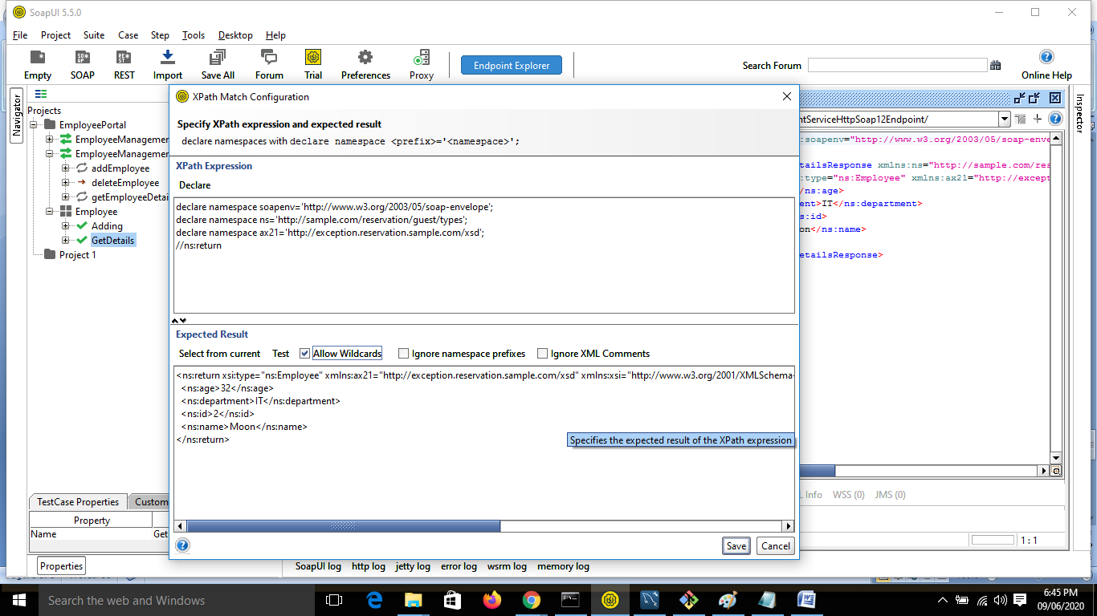

* Provide \*

